Problem 1 (25 points):
Represent the Flowchart for the problem of printing even numbers between 1 and 1000.
Solve it here please. You can add a picture of your draw.
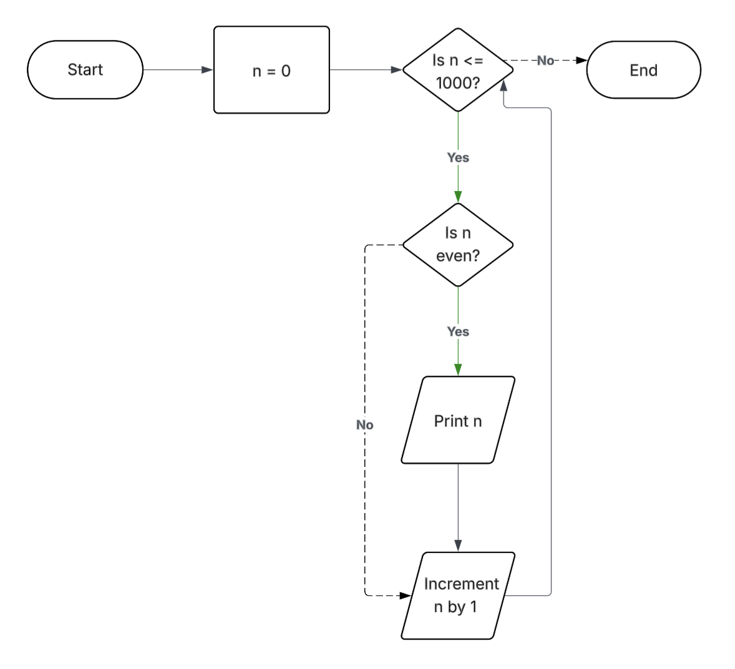

Problem 2 (25 points):
Represent an algorithm to display `all prime numbers up to a given integer n (by user) using a flowchart. The algorithm should take a single input, the integer n, and display all prime numbers less than or equal to n..***
Hints:
1- Use "num % i" to get the remainder of the division of num by i for less writing.
2- Use nested for loops when iterating with two different values. As an example, refer to the "Nested For Loop (Flowchart)" on Software Ideas Modeler. Nested For Loop (Flowchart) - Software Ideas Modeler

Solve it here please.
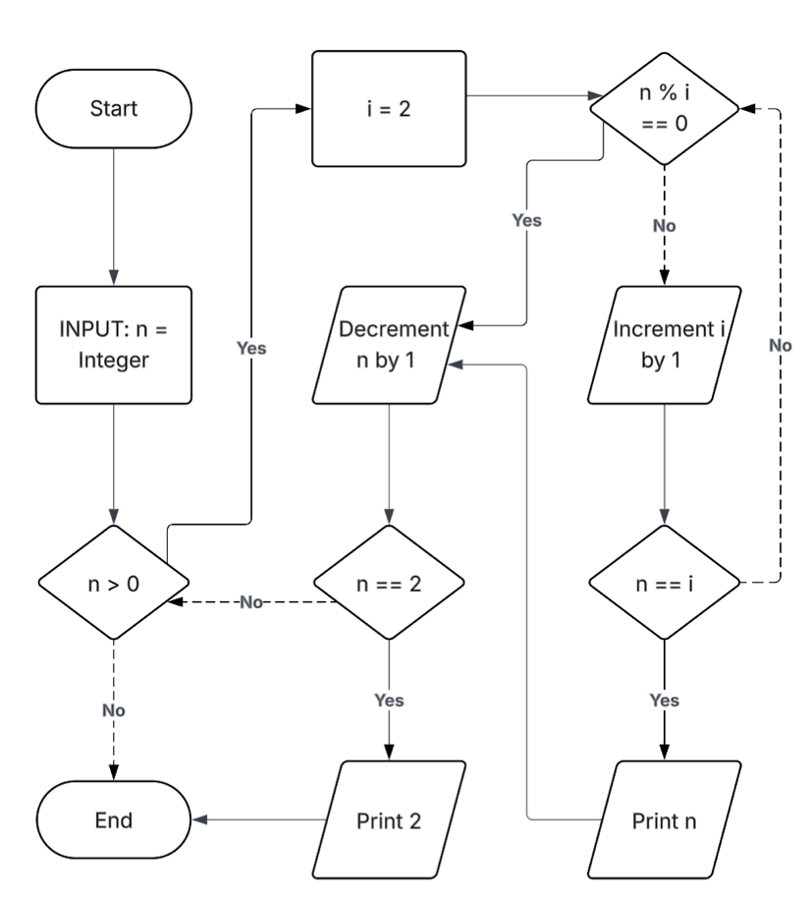

Problem 3 (25 points):
- Installing the python platform Anaconda. Anaconda allows you to:
• Easily install new Python packages using the conda system.
• Develop and run Python scripts using the Spyder IDE.
Anaconda Download (~400 MB) - https://www.anaconda.com/products/individual
You should see the following options when you install either Anaconda:
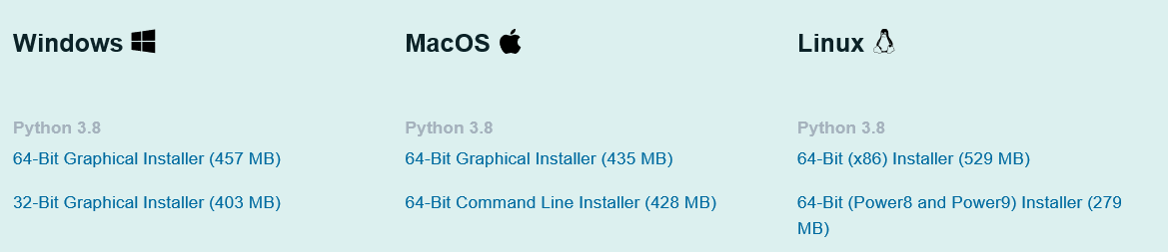
Choose the option that makes more sense for your machine. Choose Python 3, NOT Python 2!
Once you download Anaconda, install it to your machine using the default options.
To run Spyder with Anaconda, run the Anaconda Navigator.
Select "Launch" under Spyder. That's it!

Run the anaconda navigator from Start:
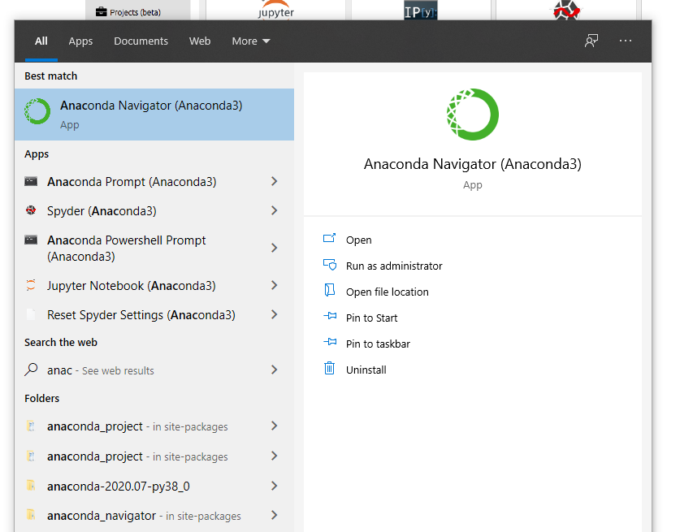


If you launch it:
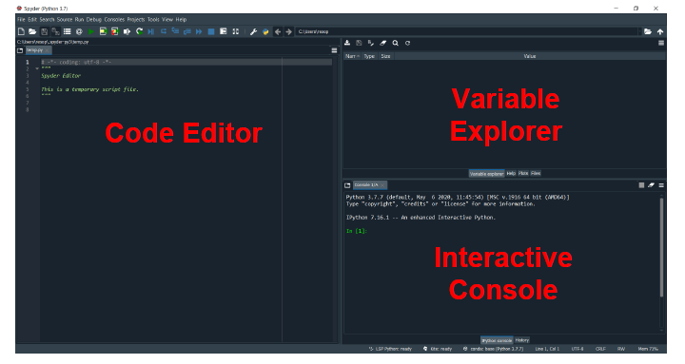
Solve it here please. You can take a snapshot and place it here.
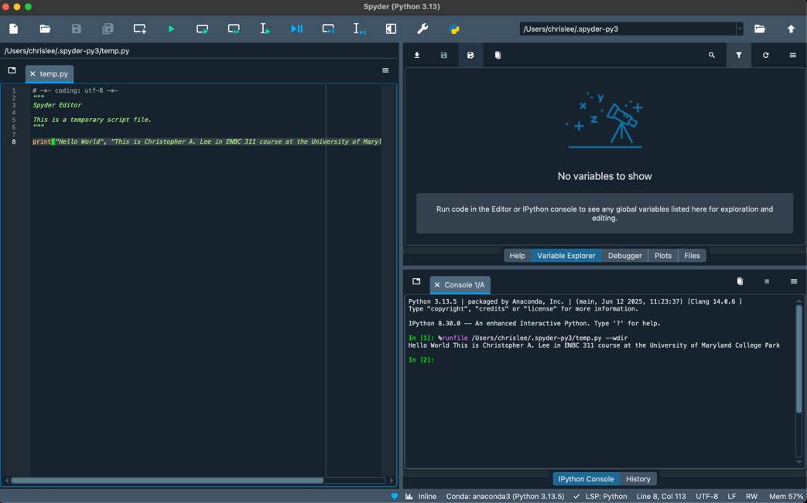
- After installing anaconda and run Spyder IDE:
In the code editor part, write the following code and run it using the green arrow or triangle:
import getpass
from datetime import datetime
def get_username():
return getpass.getuser()

username = get_username()
print(username)
now = datetime.now()
print(now)

Solve it here please. You can take a snapshot and place it here.
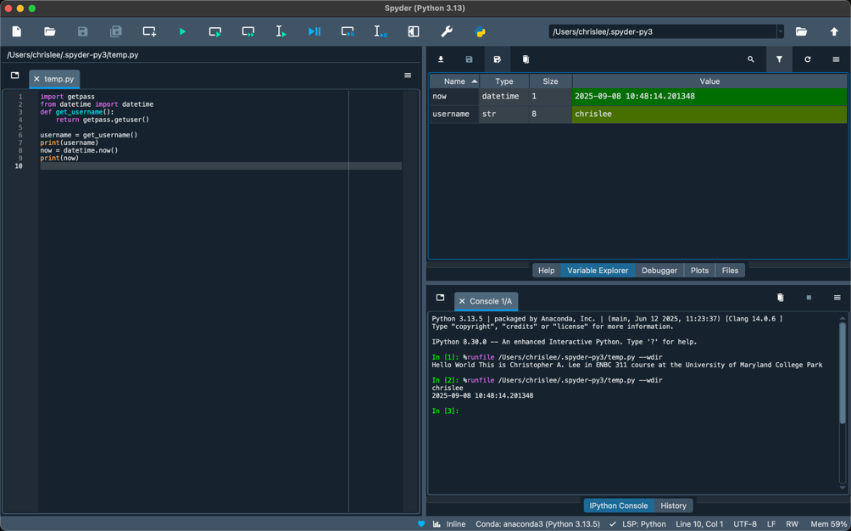
- a. Write the following code (see below), run it and please help me fix it, it is not running.
Hints: use help() function to understand what each function is doing.

def find_primes(n):
primes = []
for num in range(2, n+1:
is_prime = True
for i in range(2, num):
if num % i == 0:
is_prime = False
break
if is_prime:
primes.append(num)
return primes

print(find_primes(20)) # [2, 3, 5, 7, 11, 13, 17, 19]

Solve it here please. You highlight your inputs.
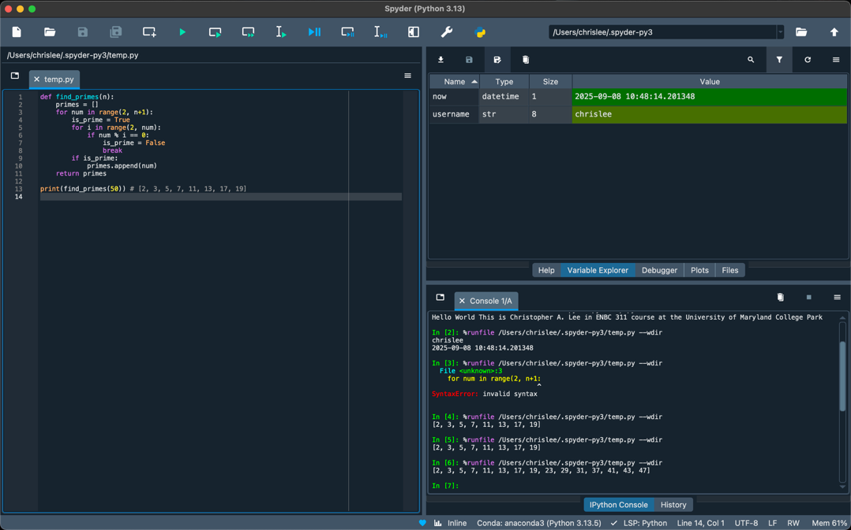

b. In one sentence, what is this code doing?

Solve it here please.
The following code finds all the prime numbers that less than or equal to the given integer by the user.

Problem 4 (25 points):
You are given a list of numbers. Write a Python program to calculate and display the mean (average) and median of these numbers.

Input:
A list of numbers (e.g., numbers = [10, 20, 30, 40, 50]).
Output:
Print the mean and median of the numbers in the list.
Example:
For the list numbers = [10, 20, 30, 40, 50]:

Expected Output:
Mean: 30.0
Median: 30
- Please do not define your own functions for now. You can use built in functions of course such as sum() and len().
- Do not use: statistics.median() function please or any other built in functions that does the direct calculation of the median.
- You should test it on other lists such as: numbers = [10, 20, 30, 40, 50, 60]

Solutions:

Solve it here please.
numbers = [10, 20, 30, 40, 50]

def mean_median_calculator(numbers):
sorted_numbers = sorted(numbers)

temp_mean = sum(numbers) / len(numbers)
temp_median = 0
if len(numbers) % 2 == 1:
temp_median = numbers[int(len(numbers) / 2)]
else:
temp_median = (numbers[int(len(numbers) // 2 - 1)] + numbers[int(len(numbers) / 2)]) / 2

return temp_mean, temp_median

mean, median = mean_median_calculator(numbers)

print(mean, median)

